**SEU/IS/22/ICT/075**

**Subject Code:**  CIS11042

**Subject Name:** PracticalEssential of ICT and PC Application

**Title: MS Excel (work with data)**

**Labsheet:**14

**Submission date :** 02/04/2025

Task 01

1. Select data 🡪 Insert 🡪 Chart 🡪 Bar chart

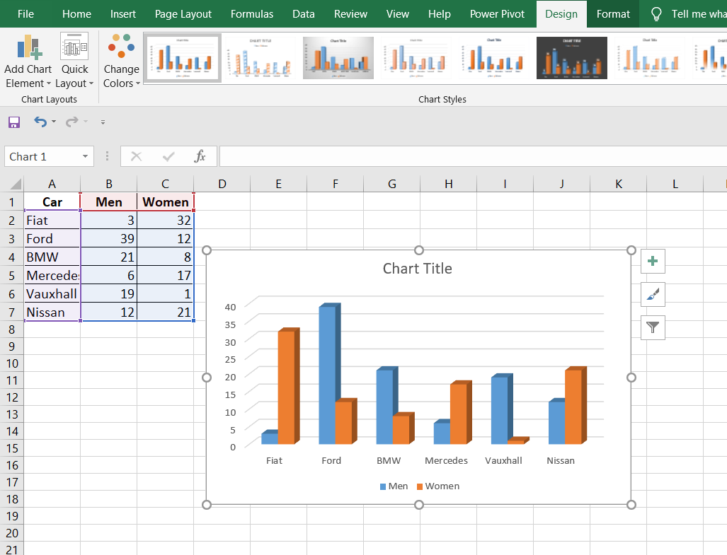

1. 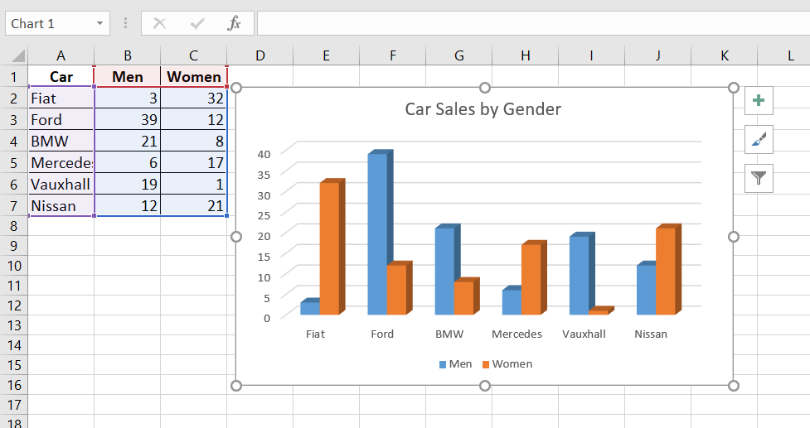Click on Title 🡪 Type title as “Car Sales by Gender”
2. Click on the chart 🡪 Add chart elements 🡪 Axis title

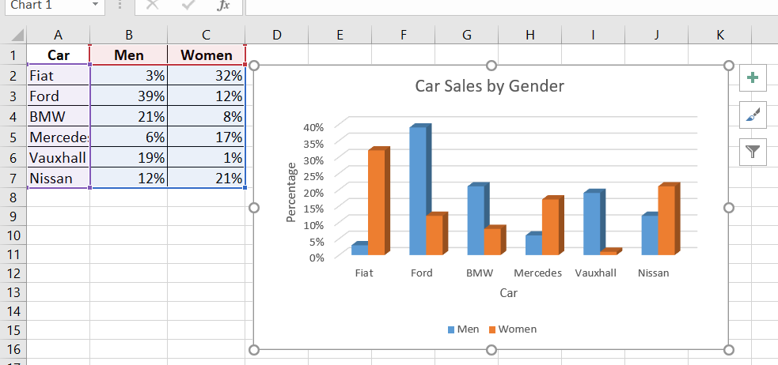

1. Click on the chart 🡪Chart design 🡪 Add chart elements 🡪 Legend 🡪 Top option

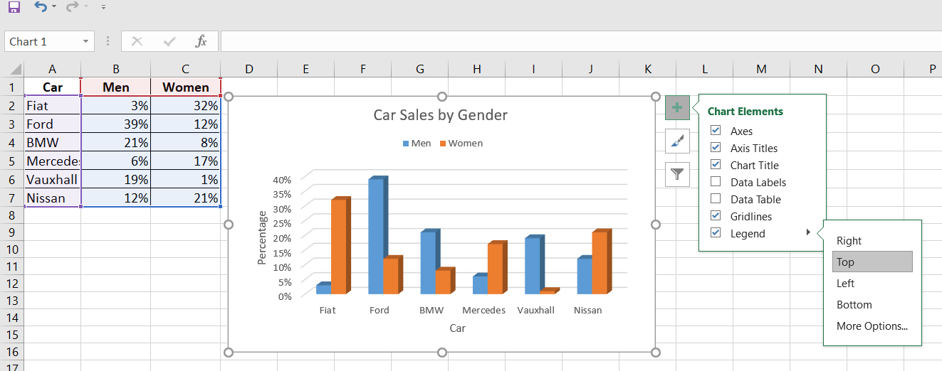

1. Click on the chart 🡪Chart design 🡪 Add chart elements 🡪 data labels 🡪 Out site option

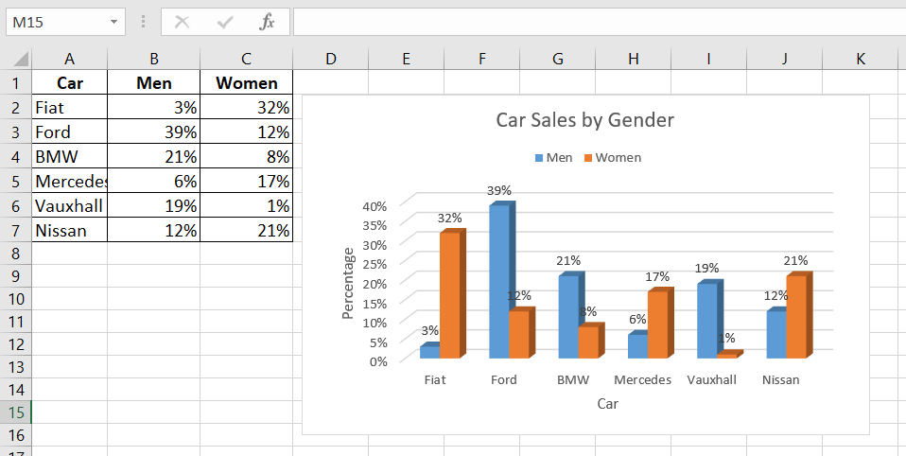

1. Click on the chart 🡪Chart design 🡪 Add chart elements 🡪 data table

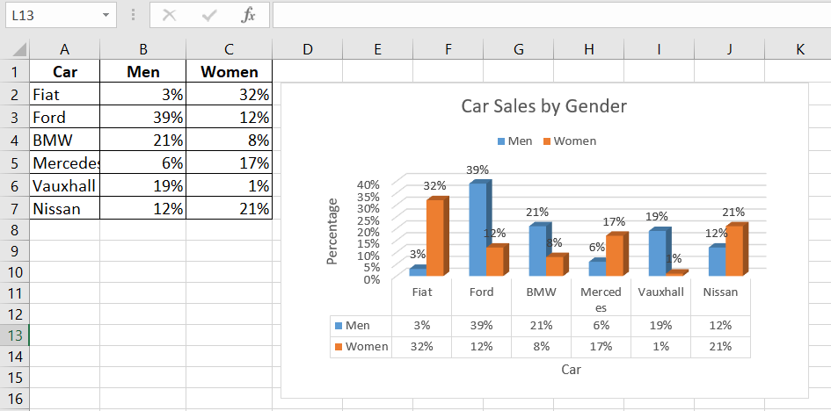

1. Click on Chart 🡪 Chart filter 🡪 categorize section 🡪 Untick “BMW” 🡪 Apply

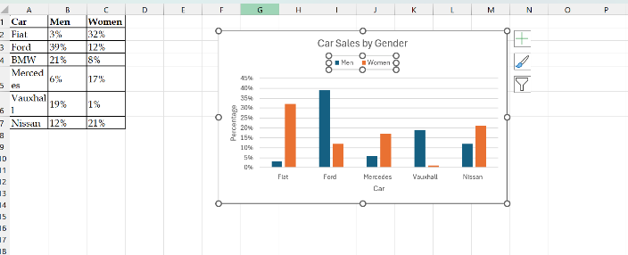

1. Click on the chart 🡪 Chart design 🡪 Switch row or column

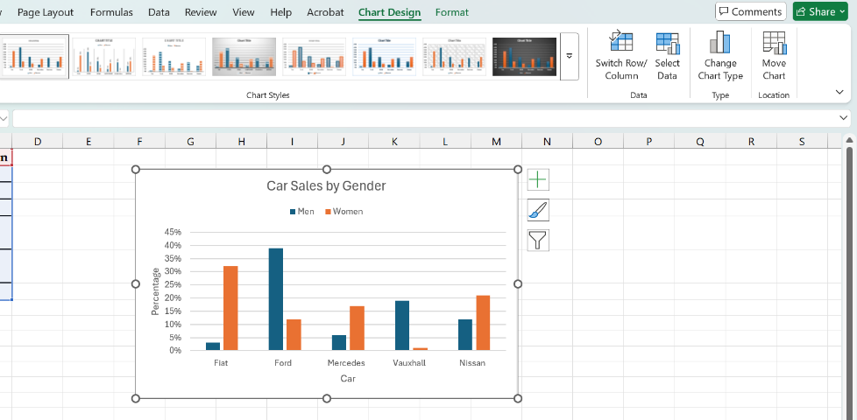

1. 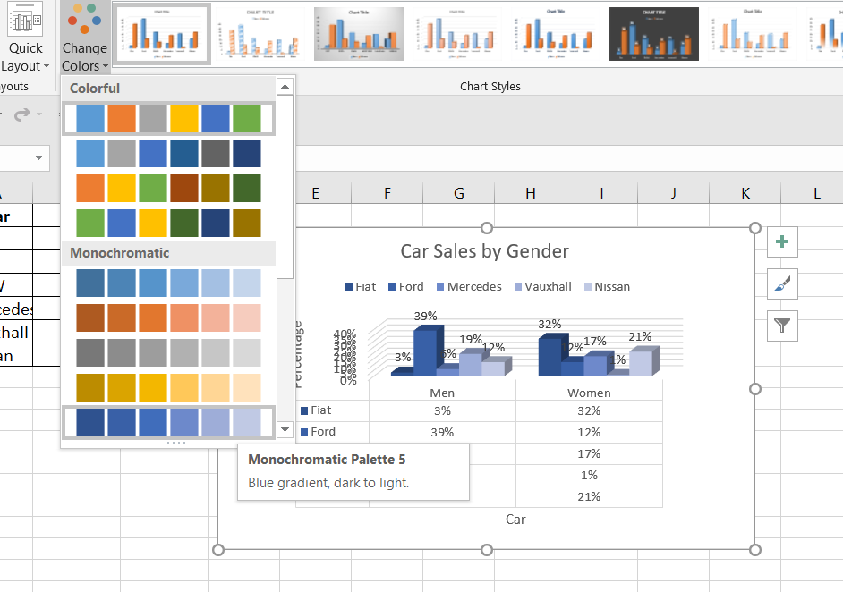Change color
2. Click on the chart 🡪 Chart design 🡪Change chart type 🡪 Choose one another chart 🡪 Ok

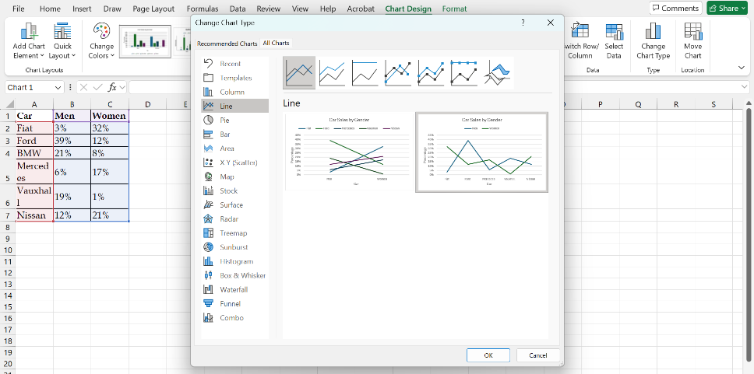

1. Select data 🡪 Click on Add option 🡪 Add name , value as “Audi, 20%, 12% “

* 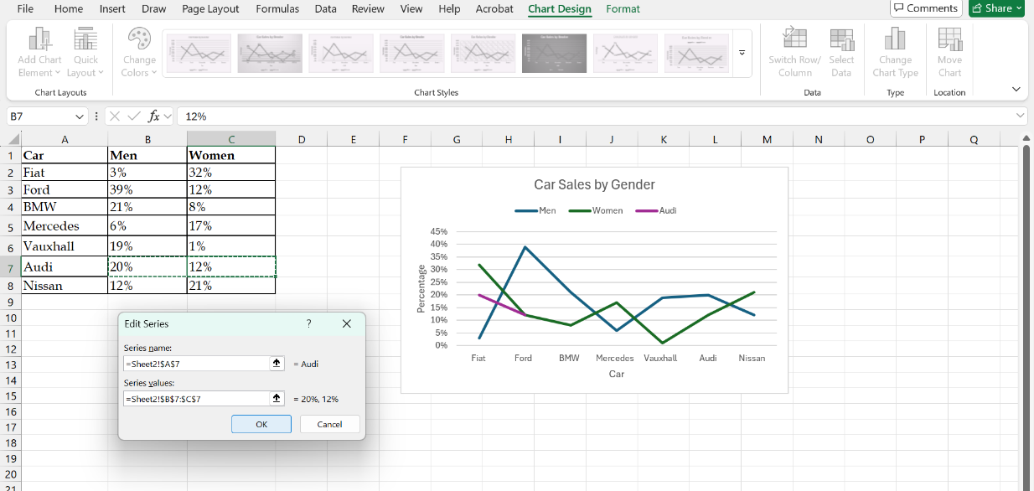Ok

1. Click on the chart 🡪 Chart design 🡪 Move chart 🡪 Choose New sheet as “Chart” 🡪 ok

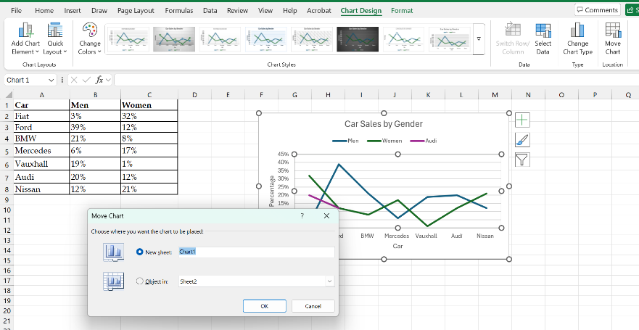

Output🡪

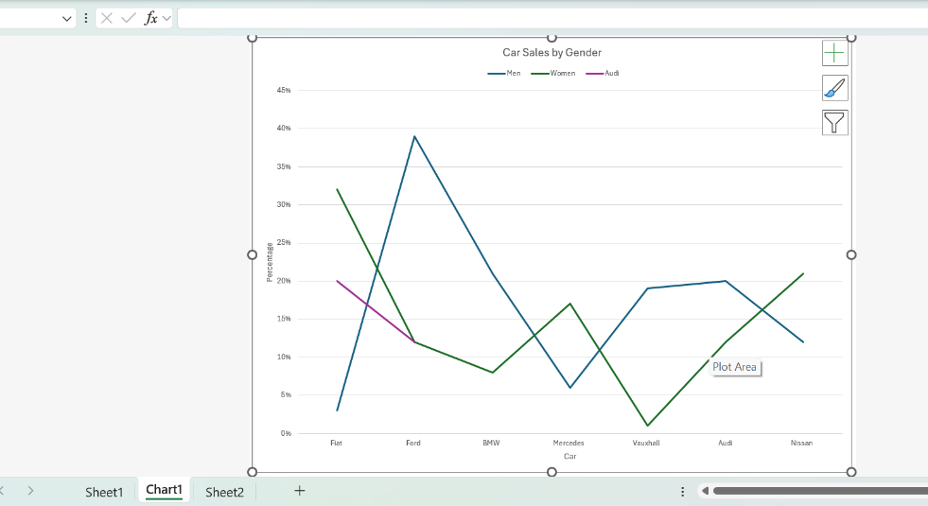

Task 03

1. A screenshot of a computer

   AI-generated content may be incorrect.
2. Insert 🡪 Spark line section 🡪 Click line 🡪 Set the range 🡪 set the path 🡪 Ok

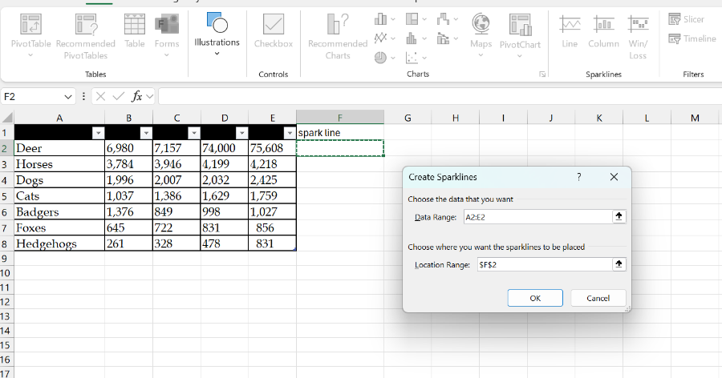

1. Select sparkline column 🡪 Sparkline menu 🡪 Sparkline color 🡪 Choose color as “Block”

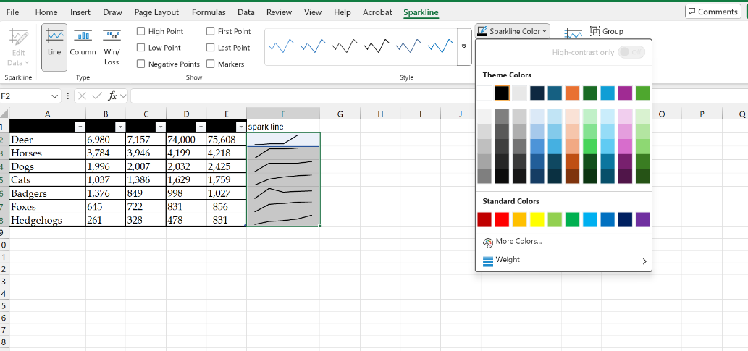

1. Select sparkline column 🡪 Show Section 🡪 Tick “High point” & “Low point”

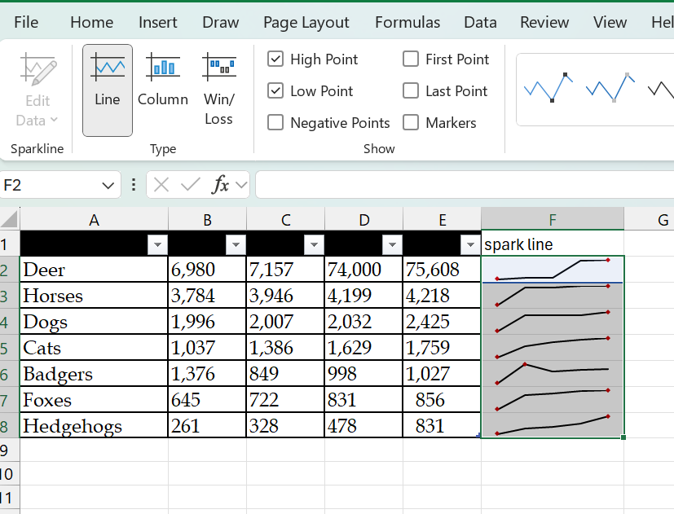

1. Select sparkline column 🡪 Show Section 🡪 tick markers

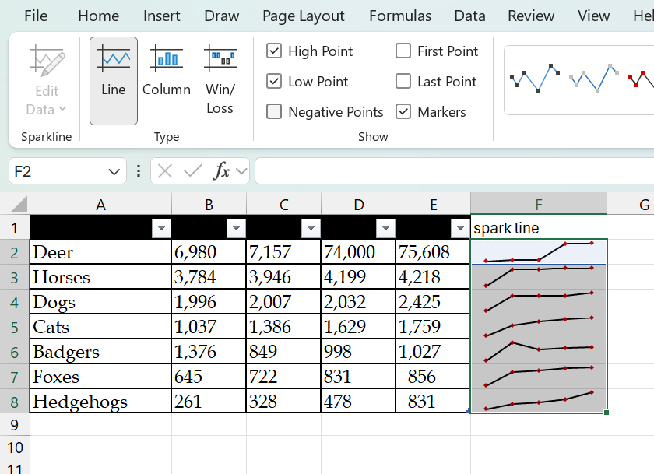

1. Select sparkline column 🡪 Sparkline section 🡪 Markers color 🡪 High point or Low point🡪

Change the color as “Yellow”, “Red”

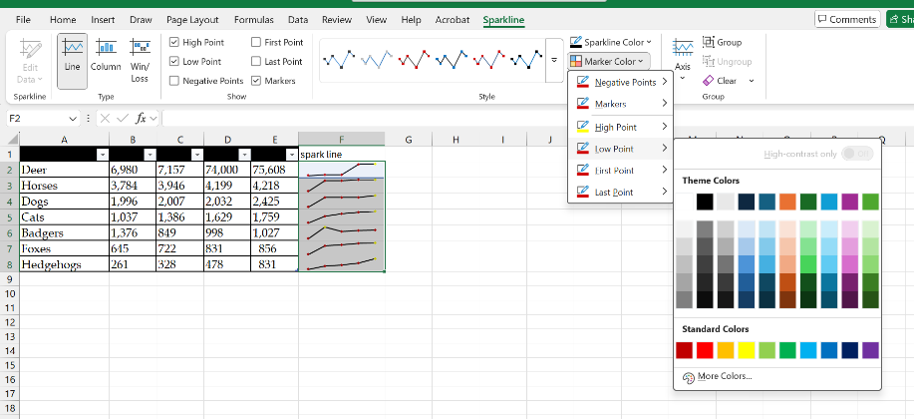

1. Select the Animal cat cell of sparkline 🡪 Spark line color 🡪 Change the color to “Green”

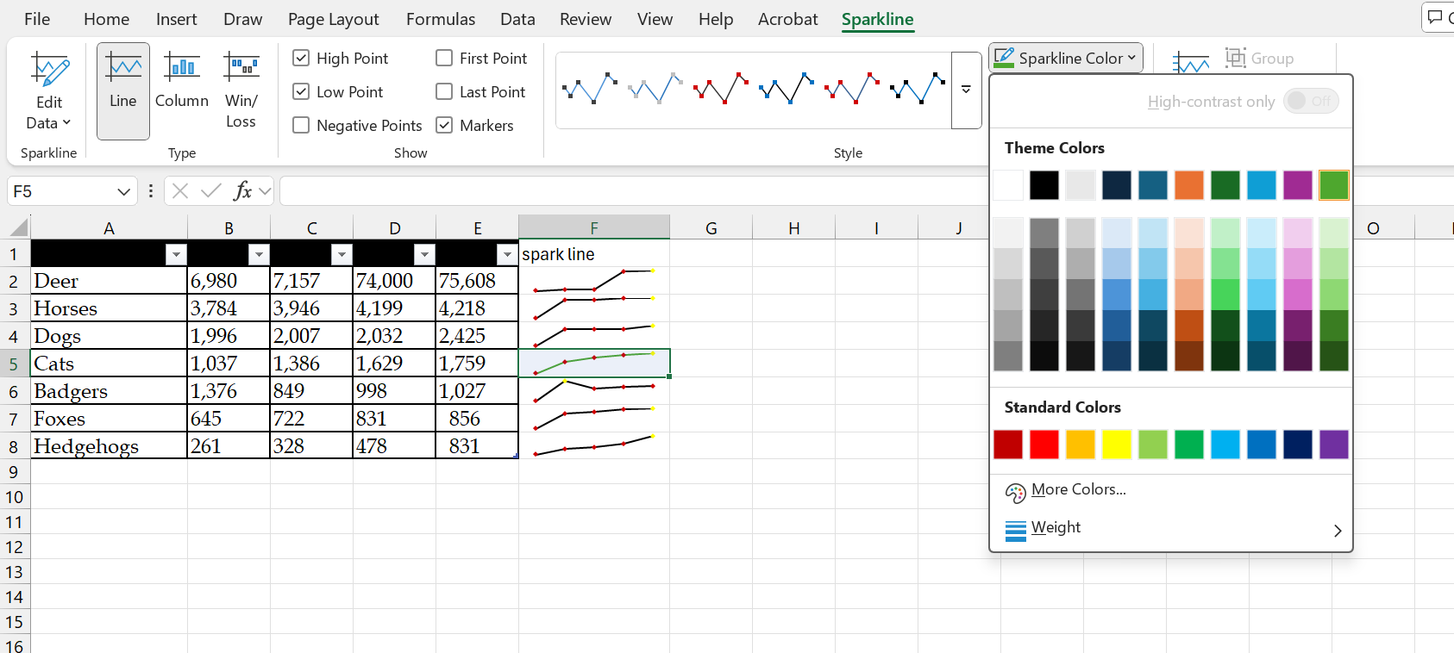

1. Insert 🡪 Spark line section 🡪 Click Column 🡪 Set the range 🡪 set the path 🡪 Ok

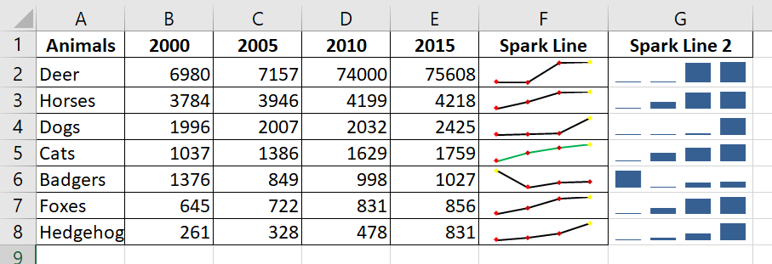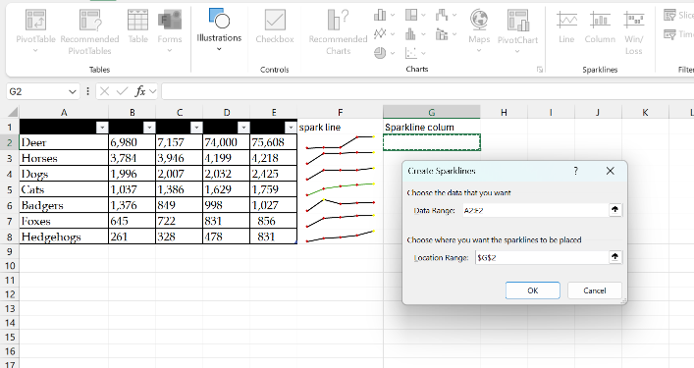

Output 🡪

1. Select sparkline column 🡪 Sparkline section 🡪 Markers color 🡪 High point or Low point🡪

Change the color as “Blue”, “Green”

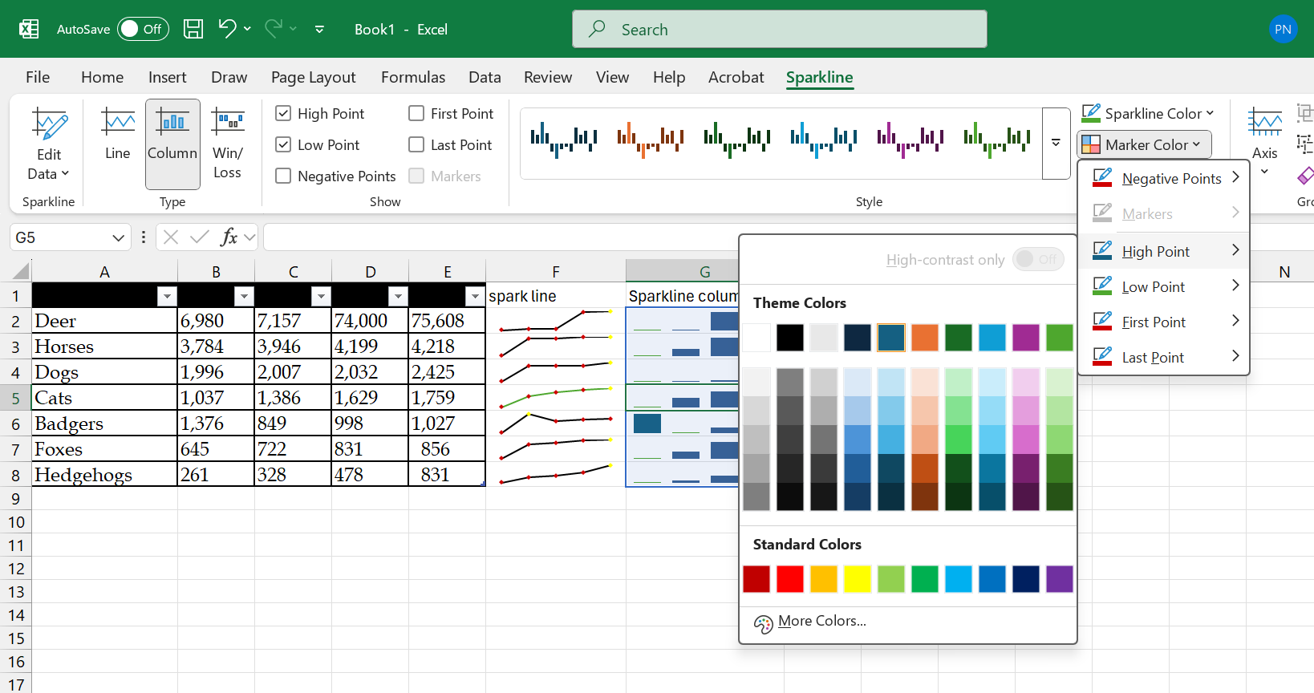



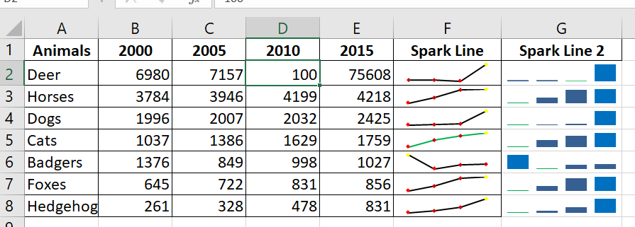

1. A graph with numbers and lines

   AI-generated content may be incorrect.

Exercise 01

1. Select each data separately 🡪 insert 🡪 Chart 🡪 Barchart

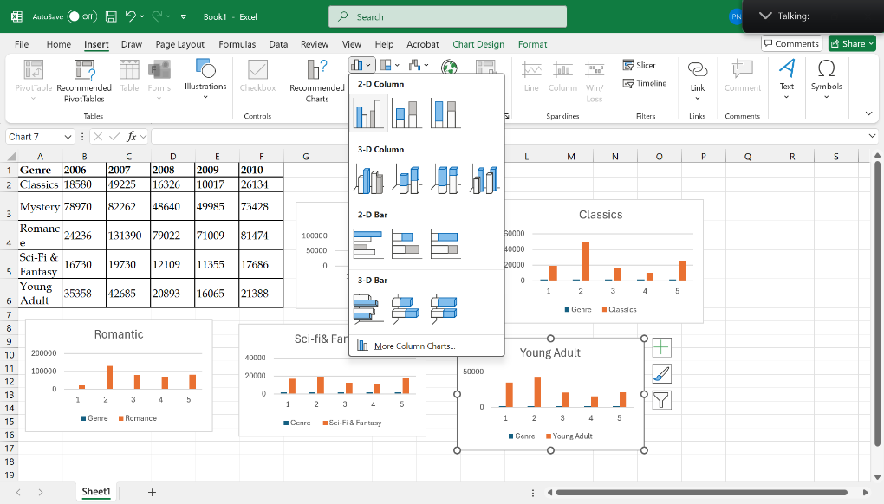

1. 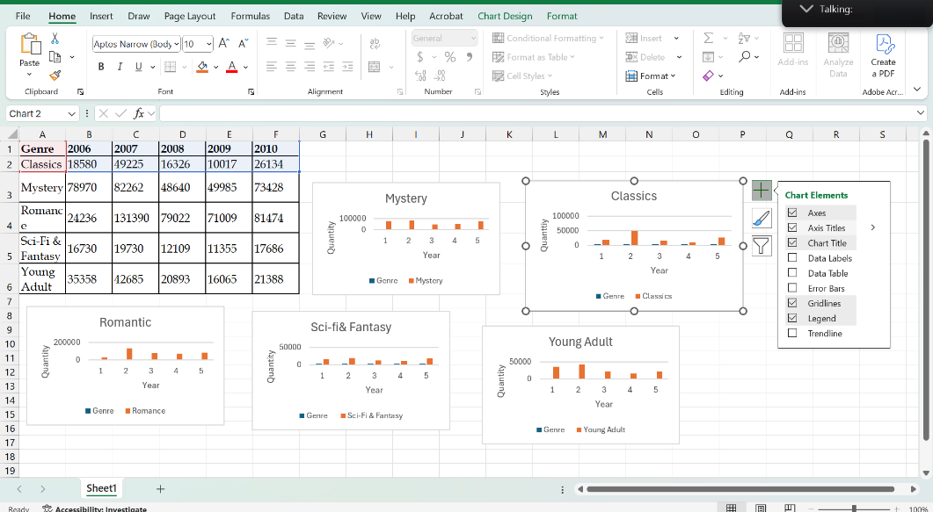Click on Chart 🡪 Click “Chart element” 🡪 Axis title 🡪 Edit as a “Year” and “Quantity”
2. Click on the chart label 🡪 select data 🡪 edit 🡪 Set the year range 🡪 Ok 🡪 Ok

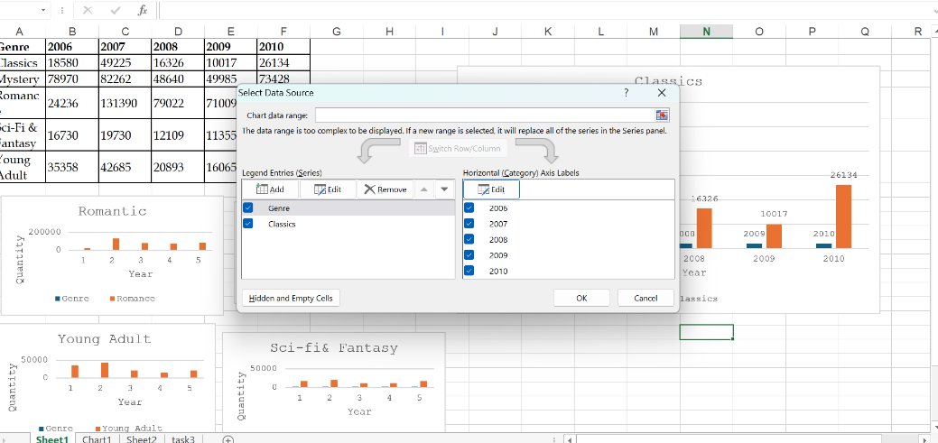

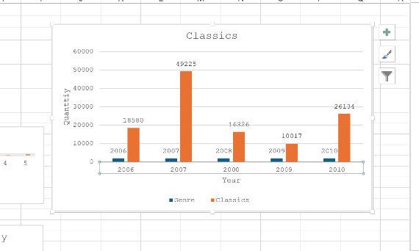

Output 🡪

1. Select the All data 🡪 Insert 🡪 Chart 🡪 Clustered column chart

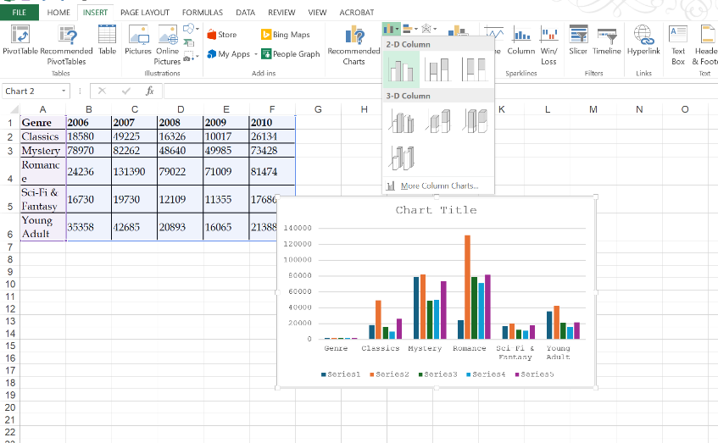

1. Click on the chart 🡪 chart design 🡪 Add chart elements 🡪 Legend 🡪 Click top option

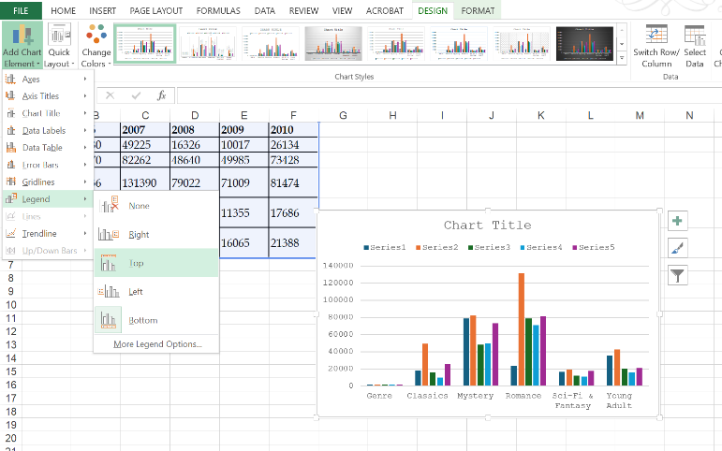

1. 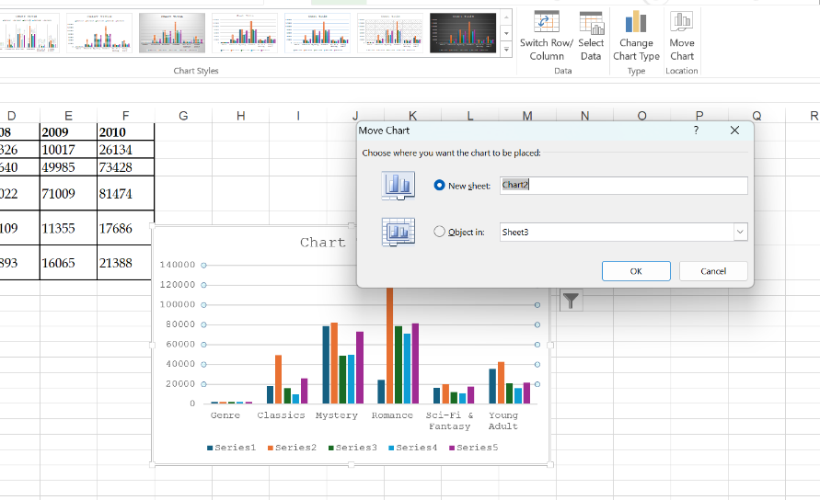Click on the Chart 🡪 Chart design 🡪 Move chart 🡪 Tick New sheet as “Chart” 🡪 ok

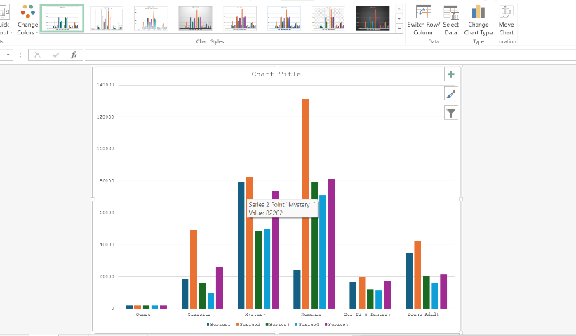

Exercise 02

1. Select the All data 🡪 Insert 🡪 Chart 🡪 Clustered column chart

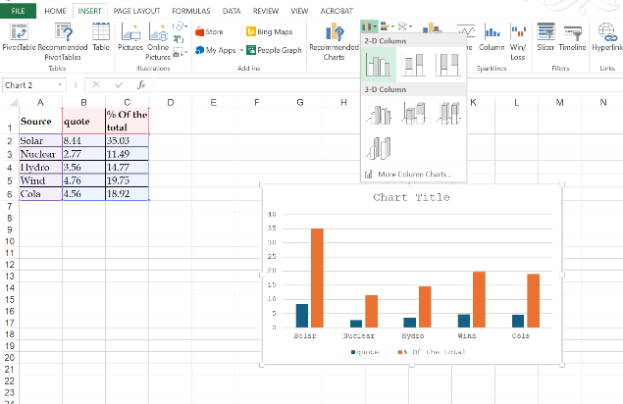

1. Click on the chart 🡪 chart design 🡪 Add chart elements 🡪 Legend 🡪 Click top option

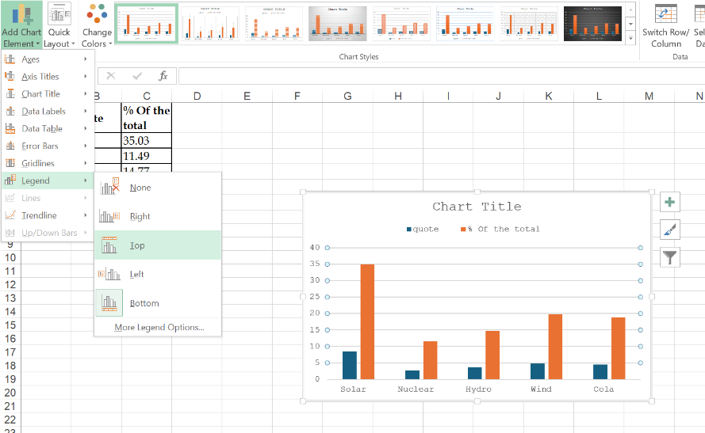

Exercise 4

1. 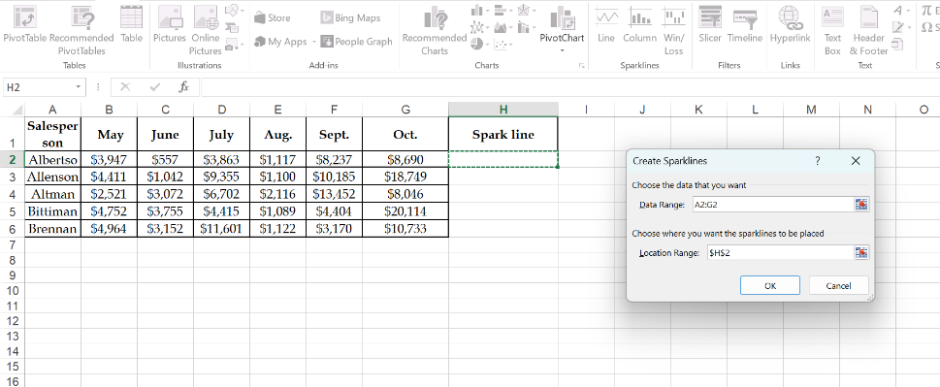On excel sheet 🡪 Insert menu 🡪 Spark line section 🡪Click “ Line” 🡪 Set range and path 🡪 Ok

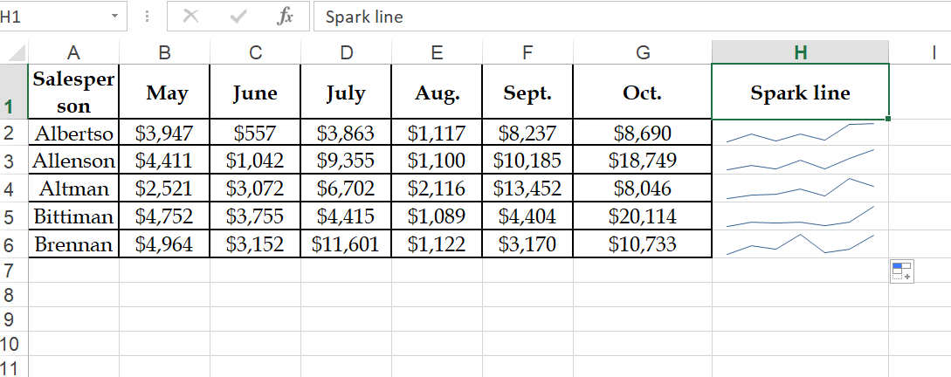

Output 🡪

1. Click on spark line column 🡪 Design 🡪 Show section 🡪 tick High point and low point

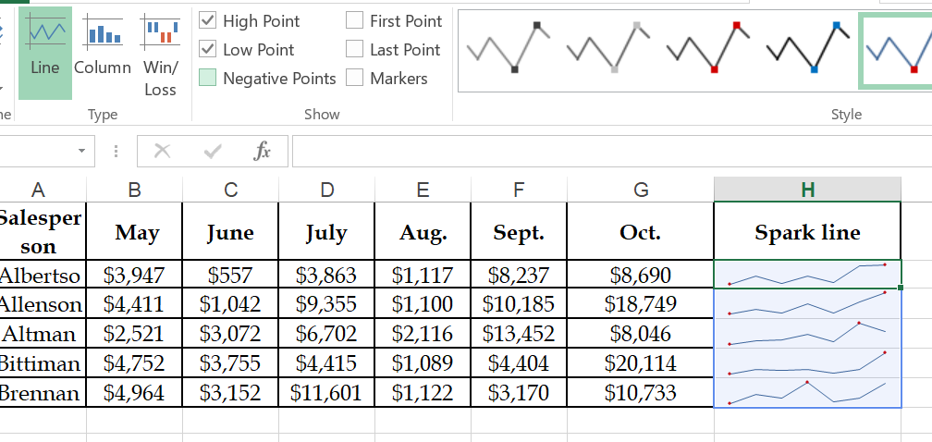

1. Click on spark line column 🡪 Design 🡪 Style section 🡪 Markers color 🡪 High point or low point🡪

Change the color to “Blue” and “green”

